Java 3 Activity 4 Task 2

30003389 – Kyer Potts

Table of Contents

Table of Contents i

List any four regular expression symbols and describe what each of them represents. 2

A text file contains random alphabet characters, with each line holds just a single character. An example is below. You will create a program that reads each line of the file as a String line and checks using a regular expression if the line has one of the 12 Grade Symbols (a, b, c, d, e, f, A, B, C, D, E, F). 3

Create a program that reads some special event days as Strings from the user and displays day, month and year separately with regular expression. 4

Given the following regular expressions, determine which of the following values for the String makes the matches method return true. The ? Symbol represents 0 or 1 occurrences of any character, the brackets [Bb] will only include one occurrence of either ‘B’ or ‘b’, and the * represents 1 or more of any character. 5

# List any four regular expression symbols and describe what each of them represents.

* Equals Versus Matches operator: “cat|dog”
  + This operator allows the or operator to be used as a regular expression within strings to shorten Boolean expressions
* Square Brackets: “[Cc]at|[Dd]og”
  + Square brackets allow multiple characters to be recognised within the string and still return true
* Include a range of characters: “[a-z]og”
  + Hyphens between characters represents a range between the two characters specified. This can be any combination of alphanumeric characters
* The Dot: “.”
  + The dot represents any single character within a string that has not been defined.

# A text file contains random alphabet characters, with each line holds just a single character. An example is below. You will create a program that reads each line of the file as a String line and checks using a regular expression if the line has one of the 12 Grade Symbols (a, b, c, d, e, f, A, B, C, D, E, F).

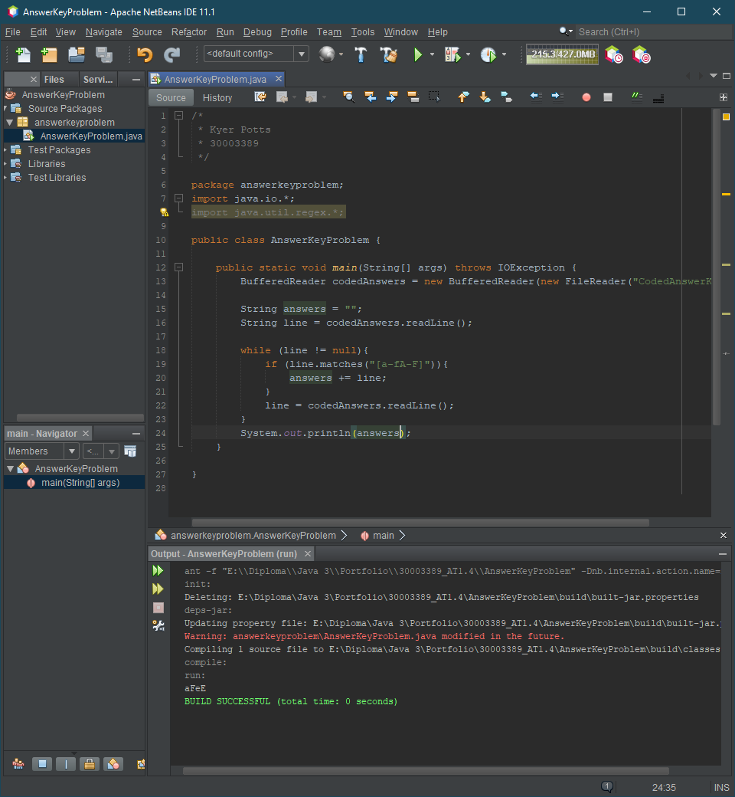

# Create a program that reads some special event days as Strings from the user and displays day, month and year separately with regular expression.

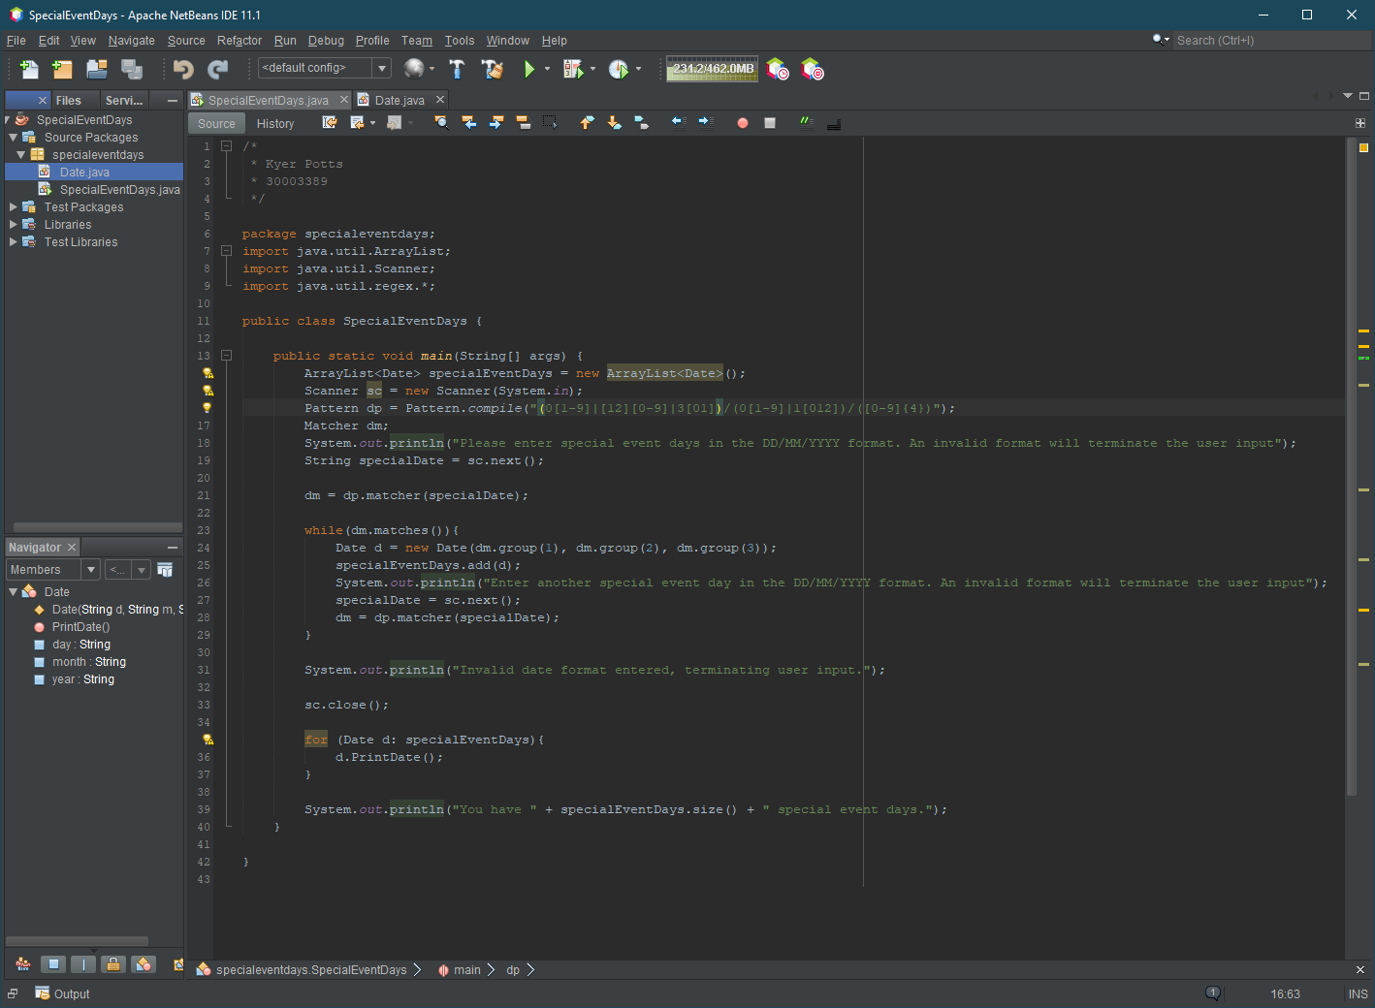

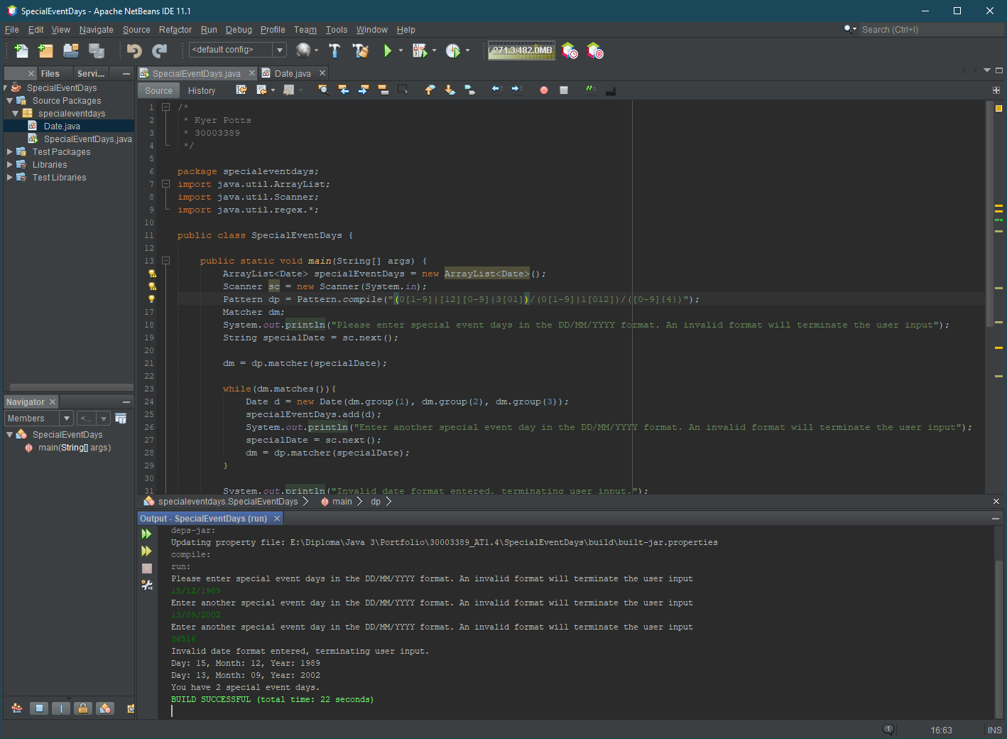

# Given the following regular expressions, determine which of the following values for the String makes the matches method return true. The ? Symbol represents 0 or 1 occurrences of any character, the brackets [Bb] will only include one occurrence of either ‘B’ or ‘b’, and the * represents 1 or more of any character.

str.matches(“?anana”);

str = “anana”; true

str = “banana”; true

str = “gabanana”; false

str2.matches(“[Bb]anana”);

str2 = “banana”; true

str2 = “anana”; false

str2 = “shanana”; false

str3.matches(“*anana”);

str3 = “montanana”; true

str3 = “anana”; true

str3 = “_anana”; true